
LjunggrenAudio RYO VC Sequencer Trig Xpander:
an Individual output expander for the RYO VC Seq

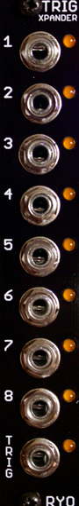

- gives your VC Sequencer 8 individual outputs, one for each step.
- 9th output that gives you a trigger for each step progression.
- All analogue circuitry.
- on board trimmer for setting the trigger length to your liking.
- slim 4HP footprint.
- compact 45mm Depth (with power cable attached).
- low power draw: 12mA +12V / 0mA -12V / 0mA +5V.
- outputs either a trigger or a gate.
- outputs are diode isolated to allow for passive output mixing.
- Can be chained to other trig xpanders or other VC Seq expanders.

downloads
* user manual
* quickstart guide
* assembly guide
* hi-res schematic
* datasheet
* BOM

